Introduction --------

Osint(open source intellligence) – it is basically gathering and analyzing the publicaly available data and some hidden data

For advance purposes.

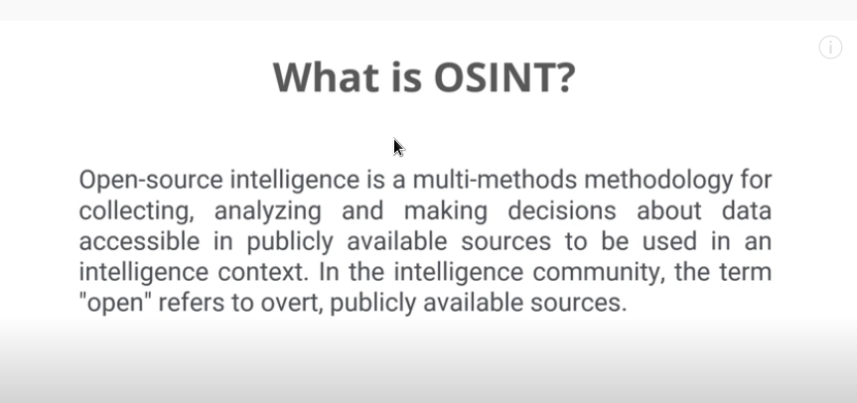

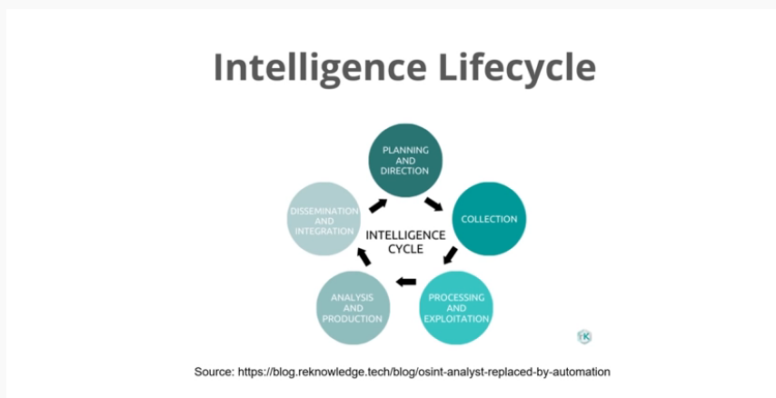

Sock puppet(aternate identity of yourself)(do not get highligted) – basically you don’t want the host to see that he is being watched therefore that we use puppets like social media fakes but to keep them legit that therefore we aren’t exposed or being highlighted.

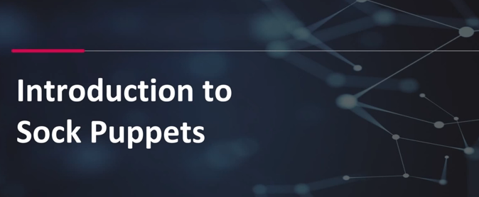

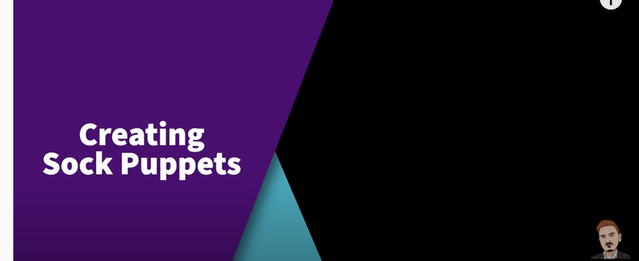

Refrences on how to create a good sock puppet-----

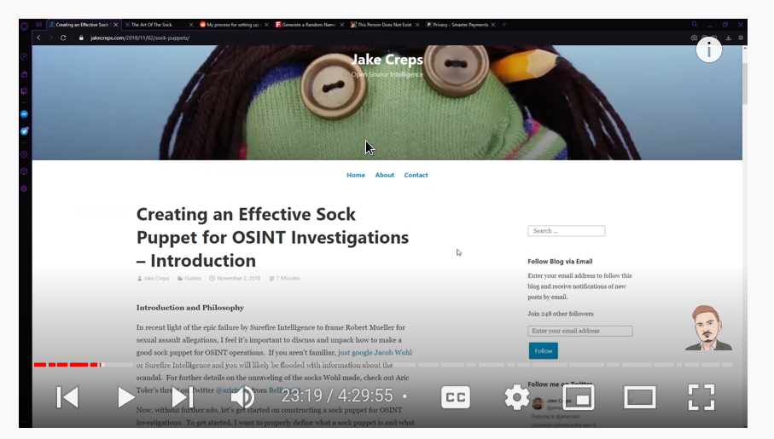

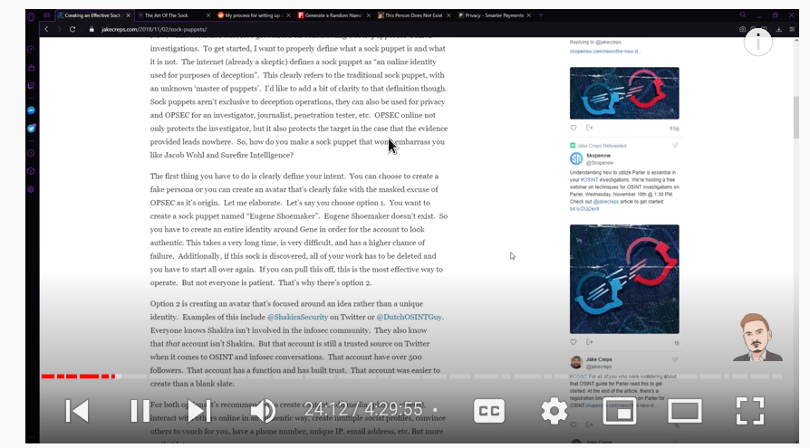

This is te fake sock account example---

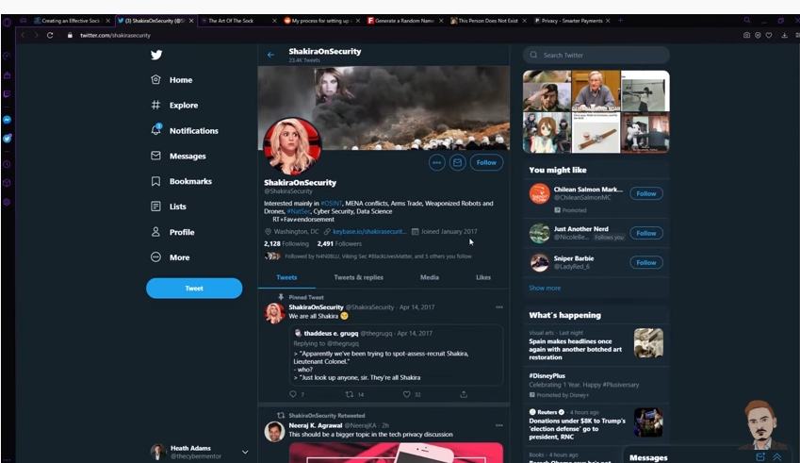

These are the basic refrences to the sock puppet----

**Sock Puppets**

Intro to Creating an Effective Sock Puppet (wayback archive): [https://web.ar](https://web.archive.org/web/20210307173507/https:/jakecreps.com/sock-puppets/)

[chive.org/web/20210307173507/https://jakecreps.com/sock-puppets/](https://web.archive.org/web/20210307173507/https:/jakecreps.com/sock-puppets/)

The Art Of The Sock - <https://www.secjuice.com/the-art-of-the-sock-osint-humint/>

My Process for Setting up Anonymous Sock Puppet Accounts(reddit) - <https://www.reddit.com/r/OSINT/comments/dp70jr/my_process_for_setting_up_anonymous_sockpuppet/>

Fake Name Generator - <https://www.fakenamegenerator.com/>

This Person Does not Exist - <https://www.thispersondoesnotexist.com/>

Privacy.com - <https://privacy.com/join/LADFC> *$5 credit given on signup

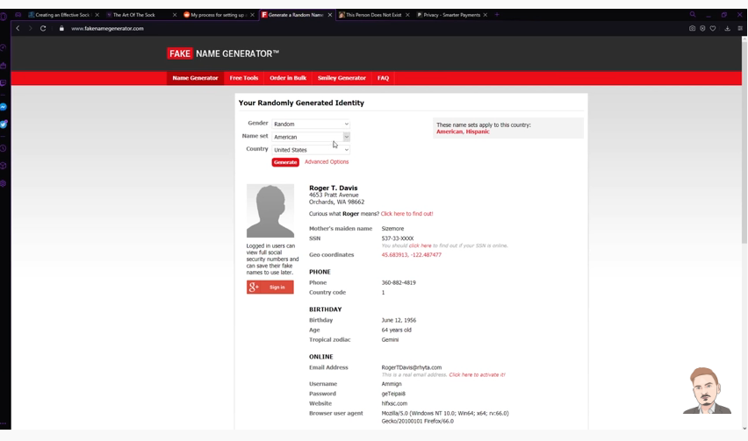

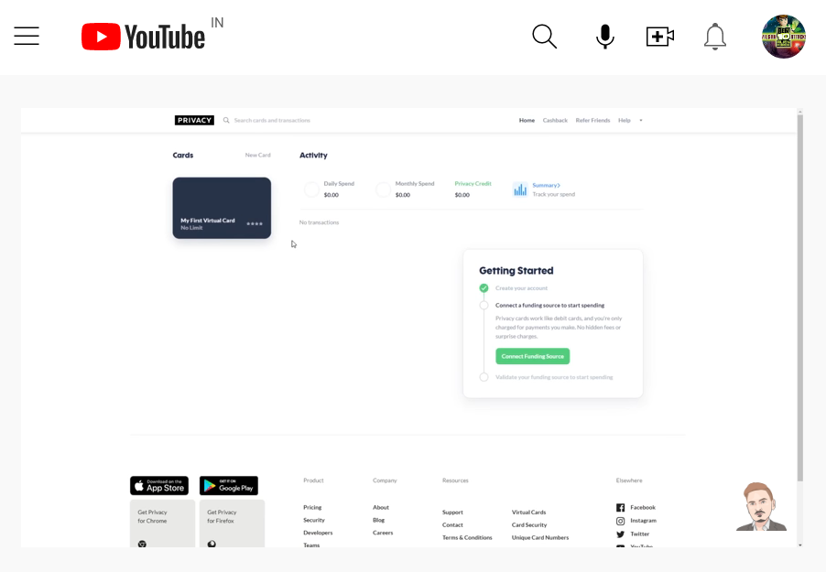

Search engines ----

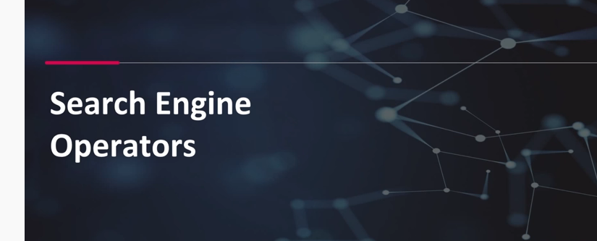

These are some different search enginges we can use for the search-----

### Search Engine OSINT

Google - <https://www.google.com/>

Google Advanced Search - [https://www.go](https://www.google.com/advanced_search)

[ogle.com/advanced_search](https://www.google.com/advanced_search)

Google Search Guide - <http://www.googleguide.com/print/adv_op_ref.pdf>

Bing - <https://www.bing.com/>

Bing Search Guide - <https://www.bruceclay.com/blog/bing-google-advanced-search-operators/>

Yandex - <https://yandex.com/>

DuckDuckGo - <https://duckduckgo.com/>

DuckDuckGo Search Guide - <https://help.duckduckgo.com/duckduckgo-help-pages/results/syntax/>

Baidu - <http://www.baidu.com/>

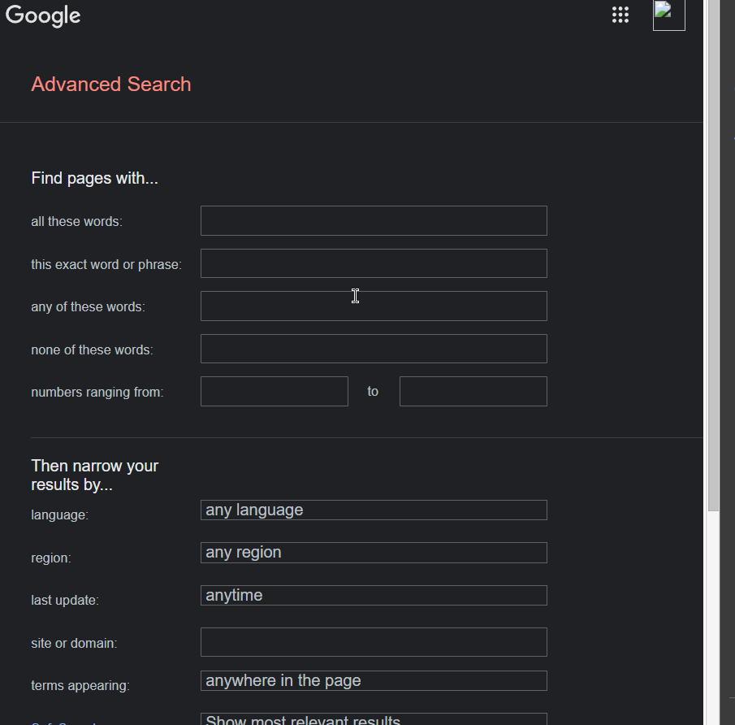

Specific searches ---

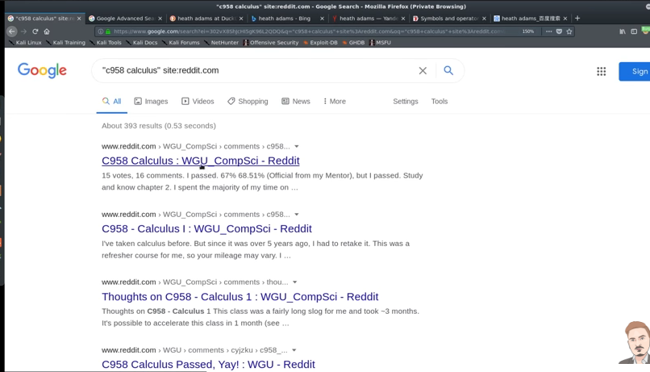

The text after * is a wildcard that it will include in the search.

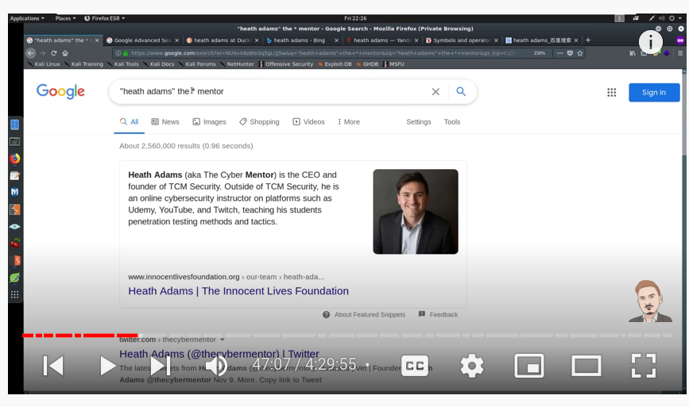

Note -- intext useful where you want the word to be available in the script.

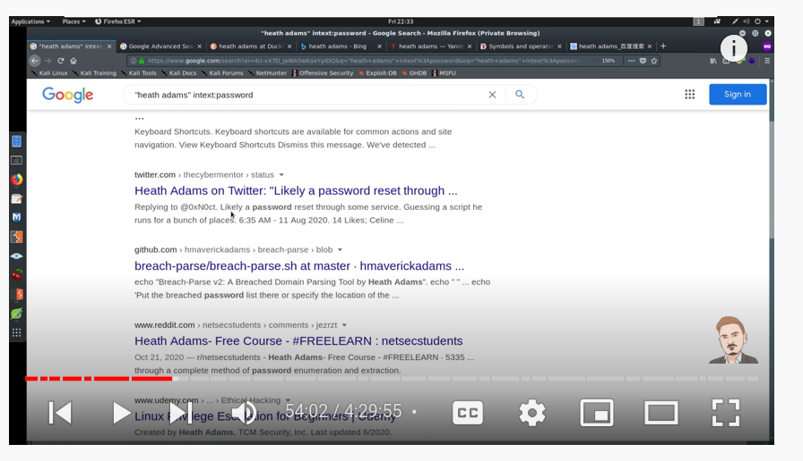

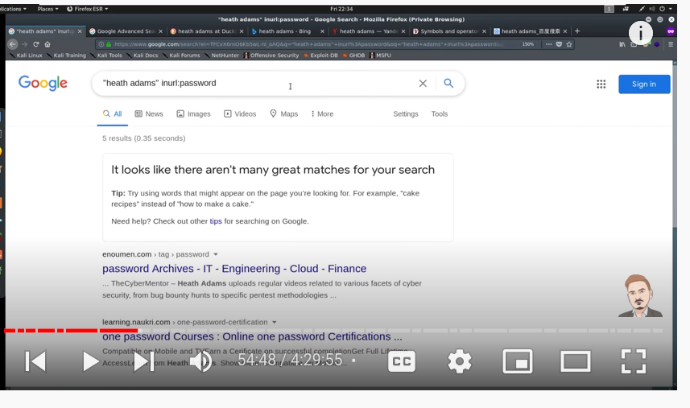

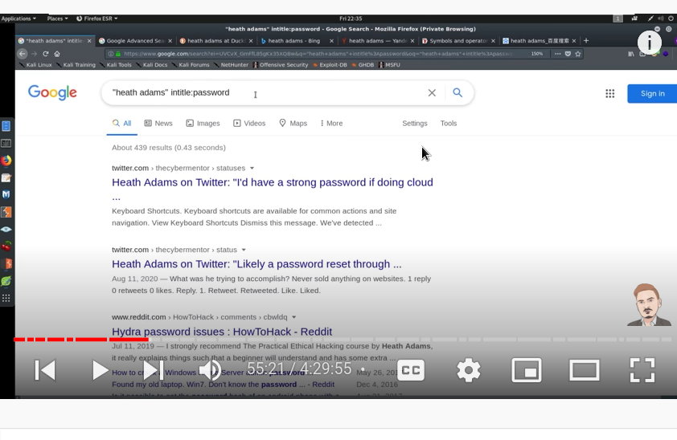

Reverse image finding --- finding that the image belongs to someone or not.

### Image OSINT

Google Image Search - [https://images.google.com](https://images.google.com/)

Yandex - [https://yandex.com](https://yandex.com/)

TinEye - <https://tineye.com>

Exif - exchangeable image file



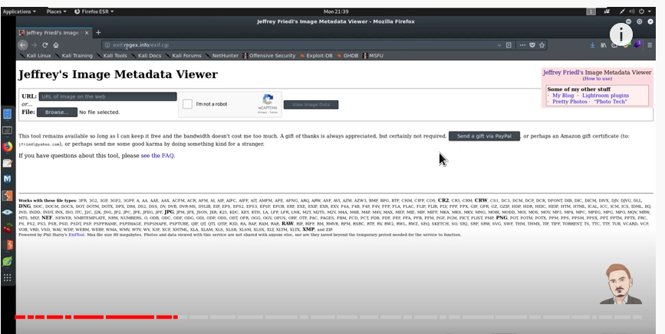

Note -these days all social media platforms strips out the exif datafrom the images.

Physical osint



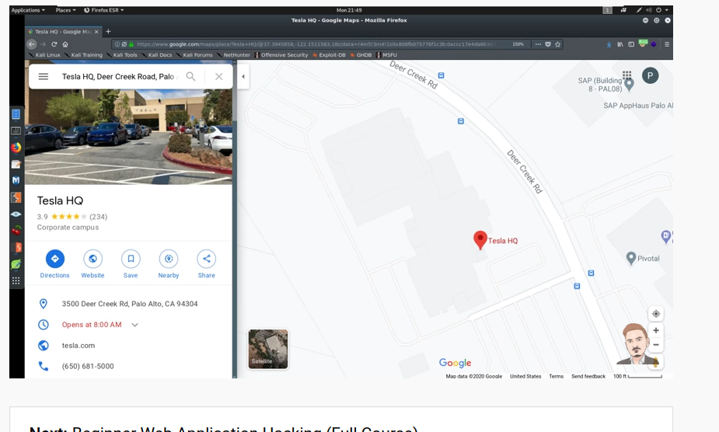





Basically getting as much info we can get from the image..

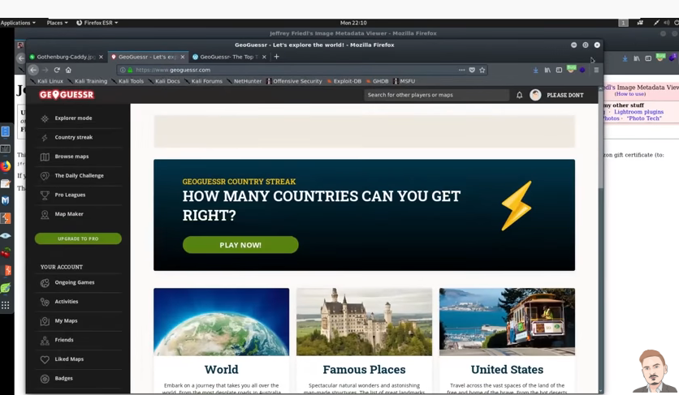

Geo guesser ---- 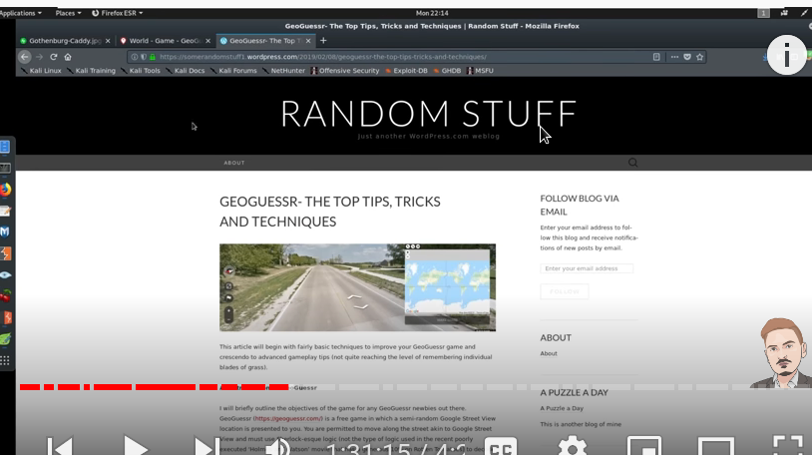

This is the website for the geo gusser info--

https://somerandomstuff1.wordpress.com/2019/02/08/geoguessr-the-top-tips-tricks-and-techniques/

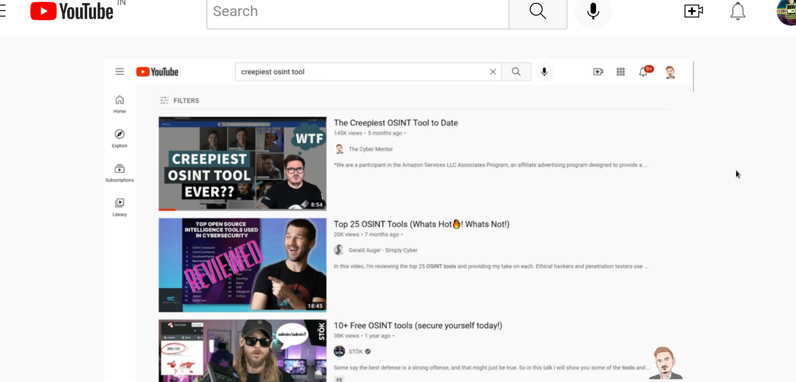

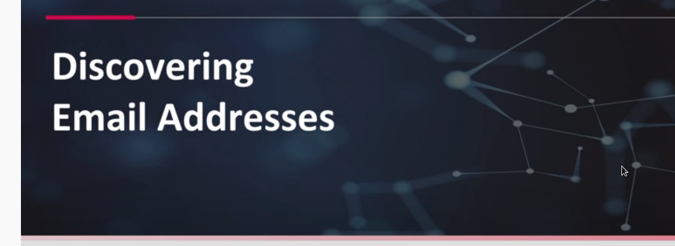

### Email OSINT

### Some tools for the email osint--

Hunter.io - [https://h](https://hunter.io/)

[unter.io/](https://hunter.io/)

Phonebook.cz - <https://phonebook.cz/>

VoilaNorbert - <https://www.voilanorbert.com/>

Email Hippo - <https://tools.verifyemailaddress.io/>

Email Checker - <https://email-checker.net/validate>

Clearbit Connect - <https://chrome.google.com/webstore/detail/clearbit-connect-supercha/pmnhcgfcafcnkbengdcanjablaabjplo?hl=en>

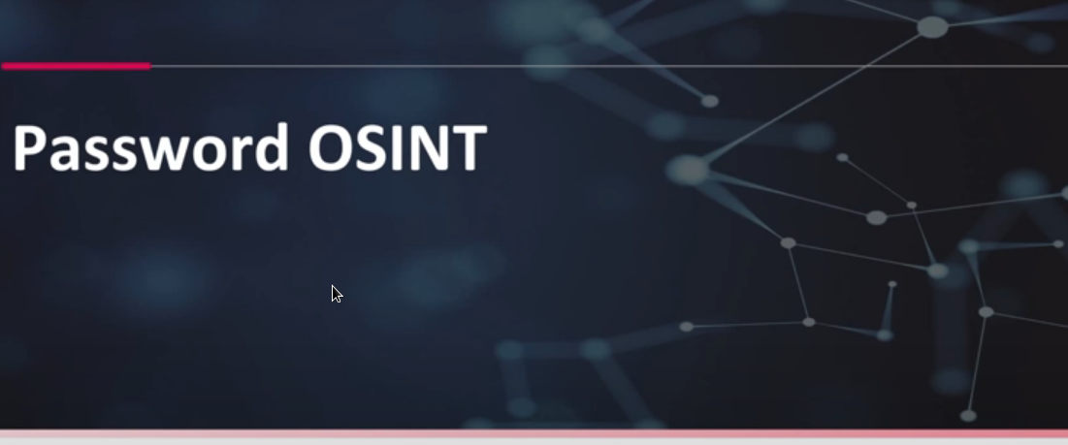

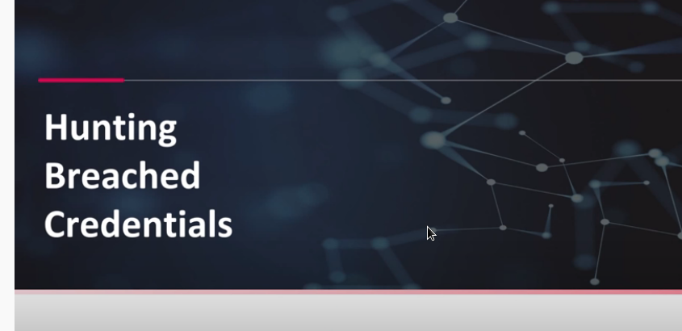

Different ways to breah data—

1. Breach-parse the offoical tool from heath
2. Dehased this tool is paid.

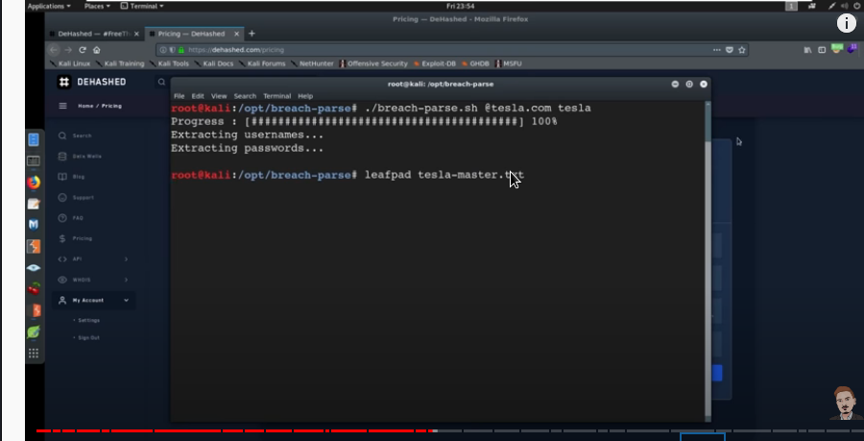

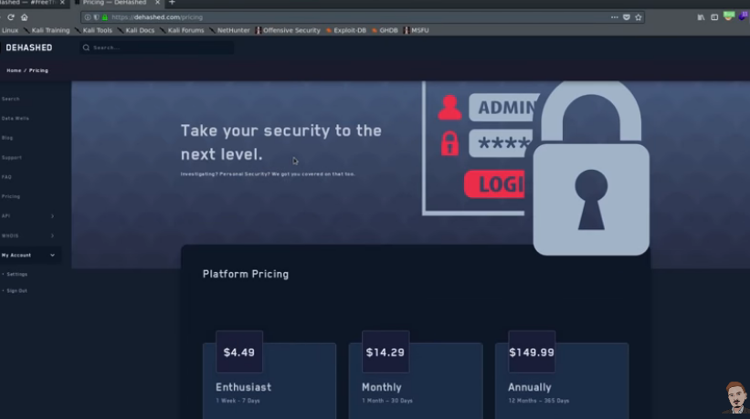

Hashes.org for searching the hashes.

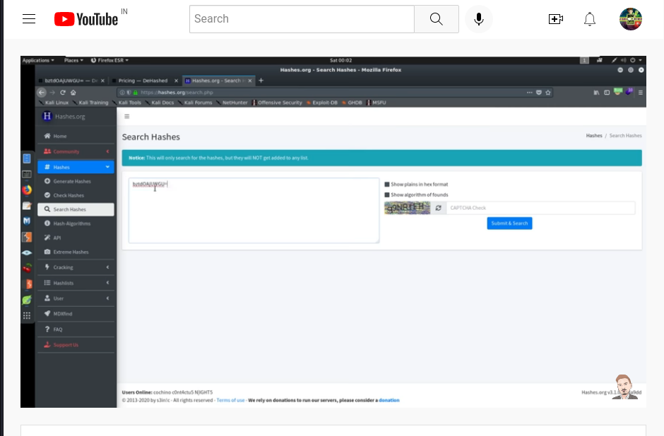

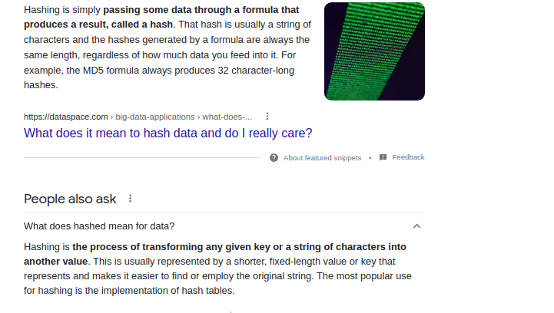

### Password OSINT

Dehashed - <https://dehashed.com/>

WeLeakInfo - <https://weleakinfo.to/v2/>

LeakCheck - <https://leakcheck.io/>

SnusBase - <https://snusbase.com/>

Scylla.sh - <https://scylla.sh/>

HaveIBeenPwned - <https://haveibeenpwned.com/>

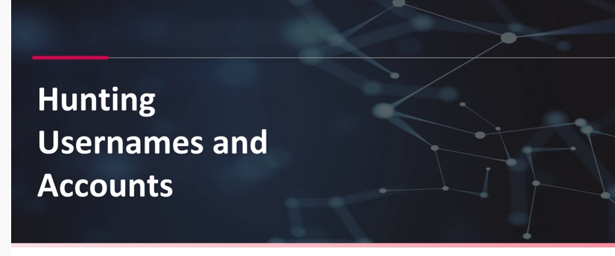

### Username OSINT

NameChk - <https://namechk.com/>

WhatsMyName - <https://whatsmyname.app/>

NameCheckup - <https://namecheckup.com/>

This what the intell I got

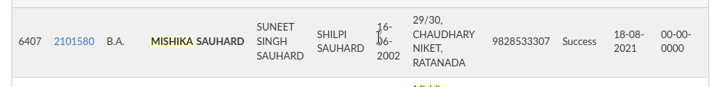

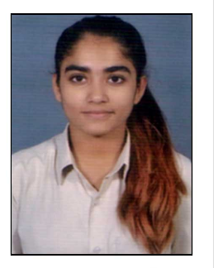

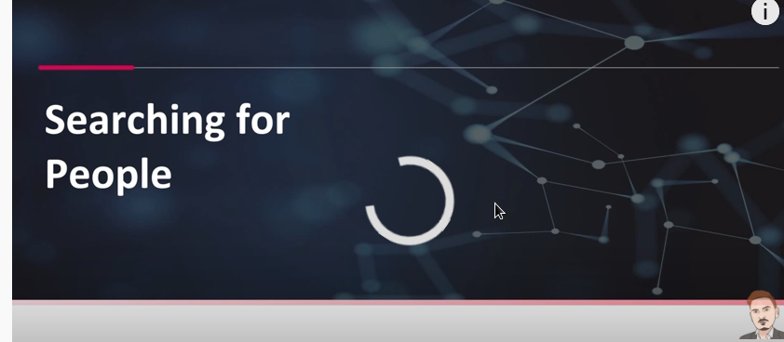

### People OSINT

WhitePages - <https://www.whitepages.com/>

TruePeopleSearch - <https://www.truepeoplesearch.com/>

FastPeopleSearch - <https://www.fastpeoplesearch.com/>

FastBackgroundCheck - <https://www.fastbackgroundcheck.com/>

WebMii - <https://webmii.com/>

PeekYou - <https://peekyou.com/>

411 - <https://www.411.com/>

Spokeo - <https://www.spokeo.com/>

That's Them - <https://thatsthem.com/>

Voter Records - [https://www.voterrecords.com](https://www.voterrecords.com/)

TrueCaller - <https://www.truecaller.com/>

CallerID Test - [https://ca](https://calleridtest.com/)

[lleridtest.com/](https://calleridtest.com/)

Infobel - <https://infobel.com/>

Hunting phone numbers--

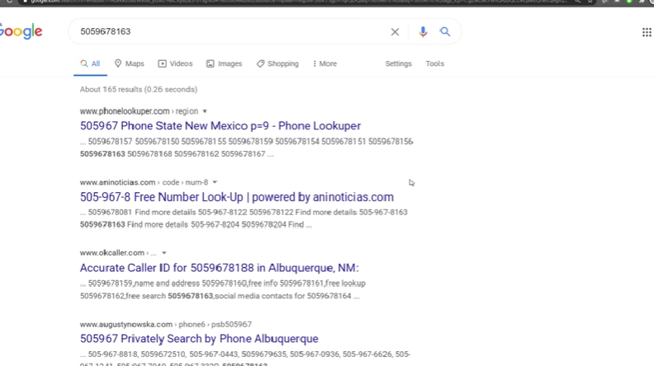

Hyphen used inusa therefore different syntaxes for different countries.

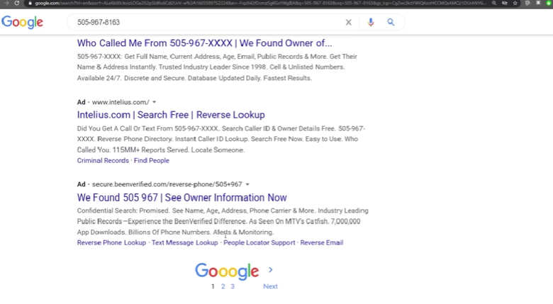

Different variations not get picked up by bot.

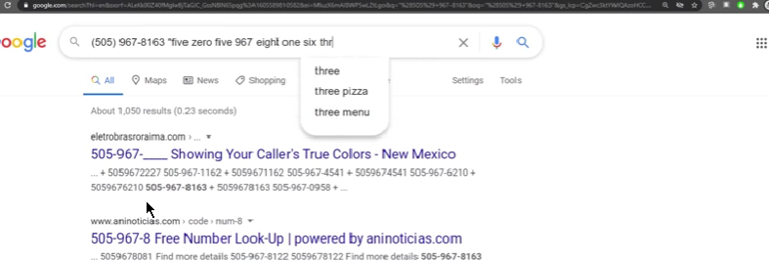

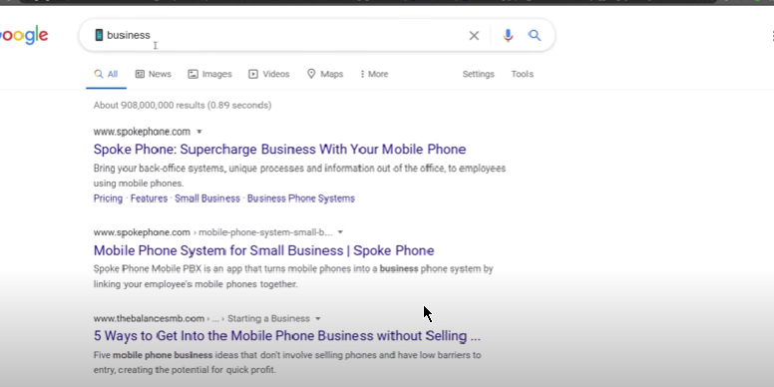

Different webistes for phone number hunting.

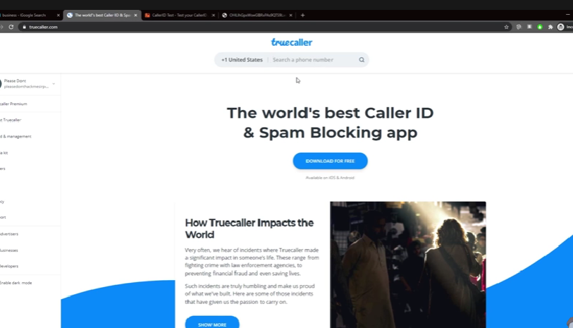

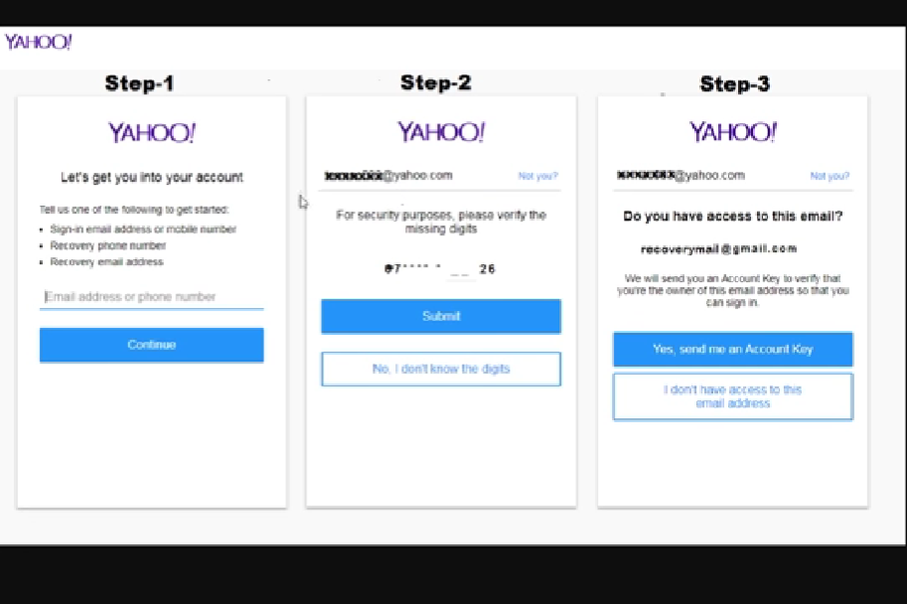

Hunting birthdates-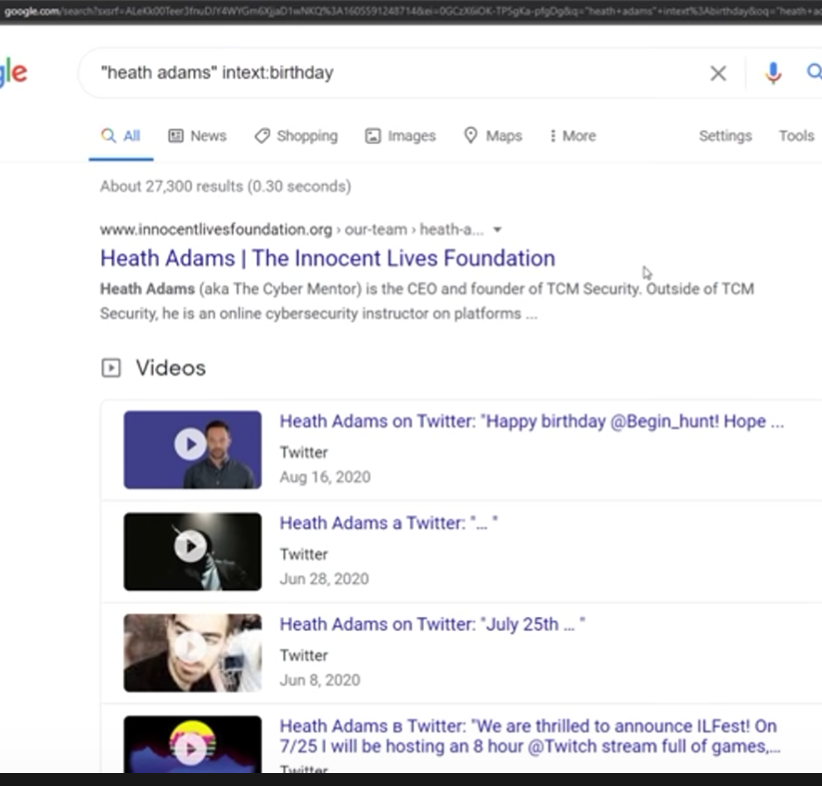

--



### Social Media OSINT

Twitter Advanced Search - <https://twitter.com/search-advanced>

Social Bearing - <https://socialbearing.com/>

Twitonomy - <https://www.twitonomy.com/>

Sleeping Time - <http://sleepingtime.org/>

Mentionmapp - <https://mentionmapp.com/>

Tweetbeaver - <https://tweetbeaver.com/>

Spoonbill.io - <http://spoonbill.io/>

Tinfoleak - <https://tinfoleak.com/>

TweetDeck - <https://tweetdeck.com/>

Sowdust Github - <https://sowdust.github.io/fb-search/>

IntelligenceX Facebook Search - <https://intelx.io/tools?tab=facebook>

Wopita - <https://woptia.com/>

Code of a Ninja - <https://codeofaninja.com/tools/find-instagram-user-id/>

InstaDP - <https://www.instadp.com/>

ImgInn - <https://imginn.com/>

Snapchat Maps - [https://map.snapchat.com](https://map.snapchat.com/)

These are some twitter tools which tracks on people timeline and then tell you about their routine.

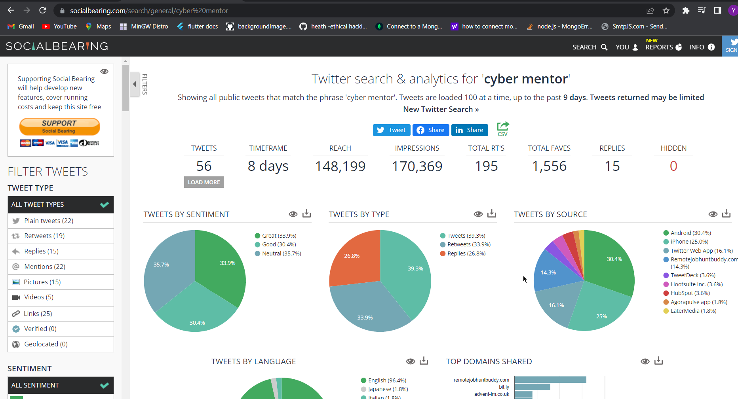

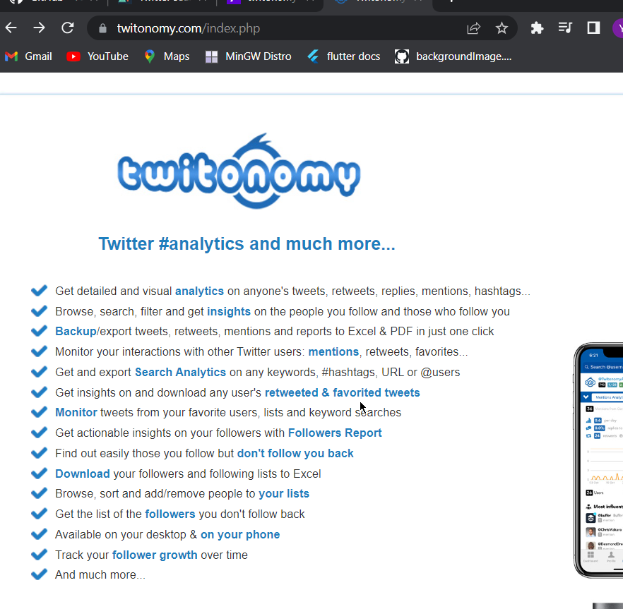

On twitonomy we can have our timeline as well as other people timeline

Tweet beaver we can generate a twitter id from that we can track on the account even if the id name is changed.

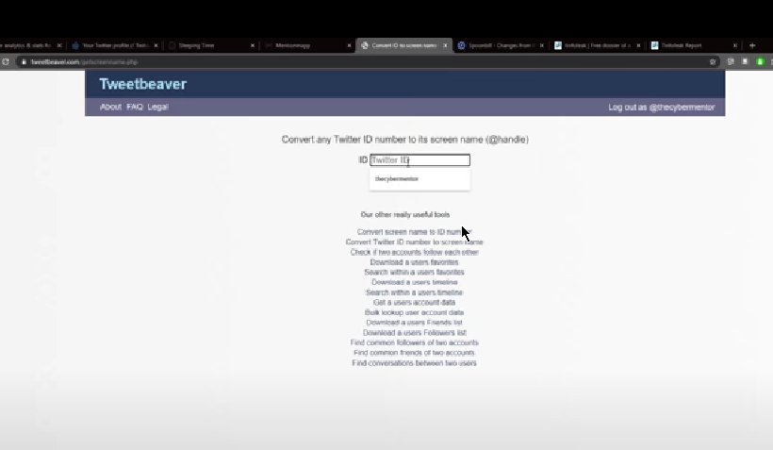

Spoonbell tells that the data changed on the id or any changes in the id.

Without logiin in.

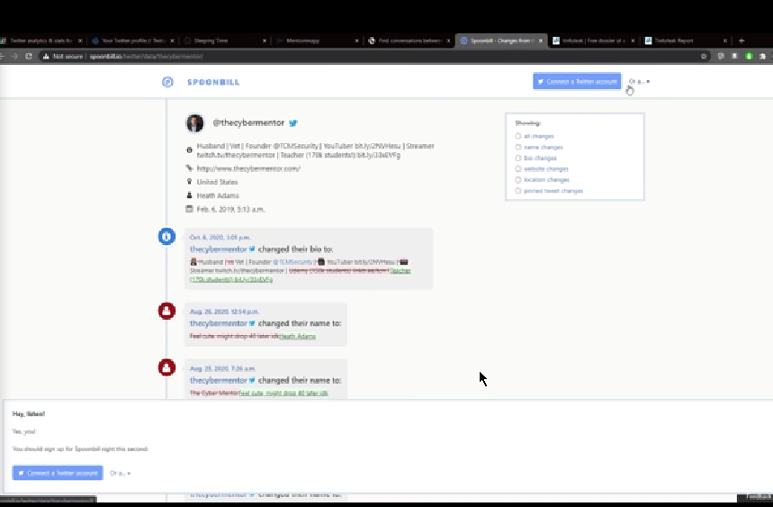

Gives the leaks about the id

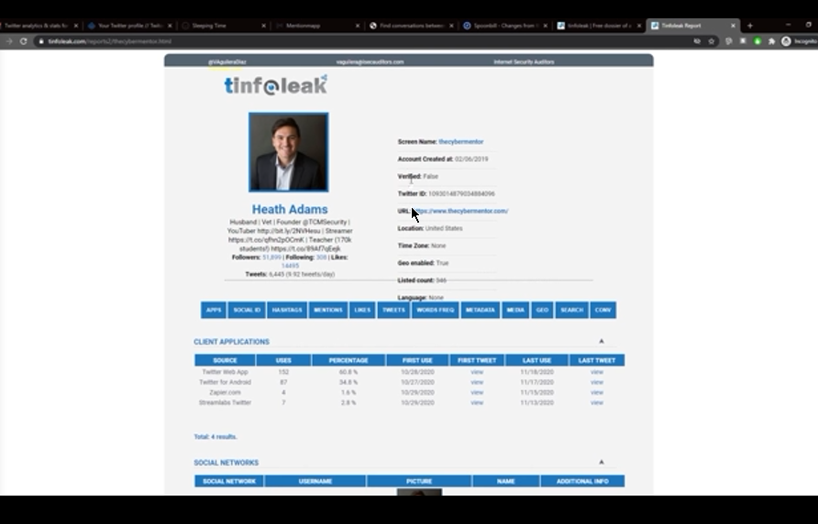

Basically we can do multiple things at the same page

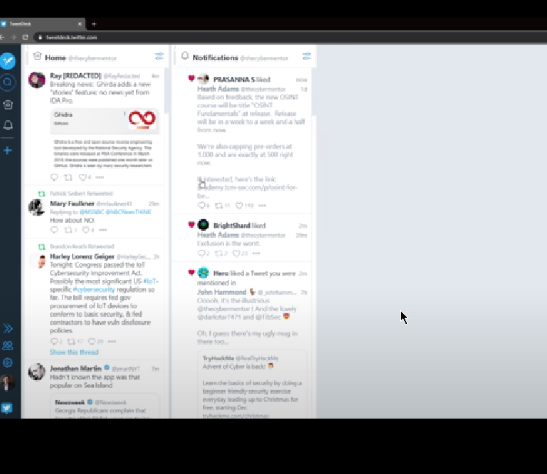



Instagram oosint

Finding the user id which changed their username.(code of a ninja)

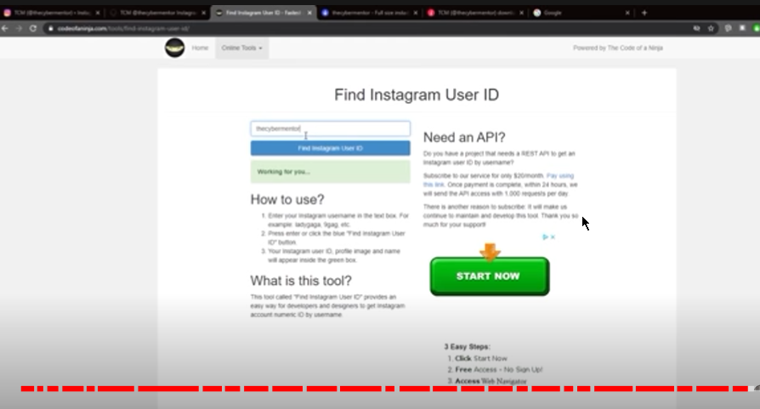

Instadp Is another website from which we can download the images of instagrams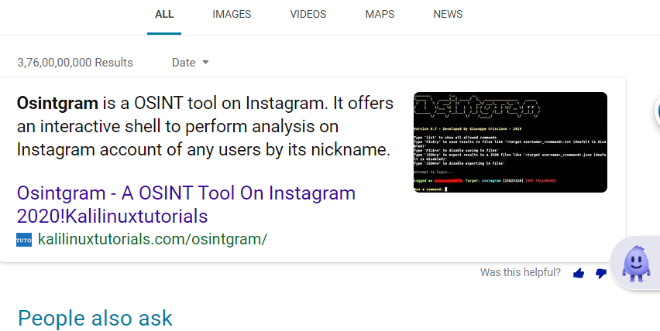

Snapmap from snapshot is a fantastic tool .

Reddit is very less in existence therefore we are not considering much.`